Winter Well

2025/26 seasonal campaign

Each winter, the National Health Service experiences increased pressure due to the circulation of seasonal viruses that can make people very unwell. The materials below are designed to help reduce pressures on the system in Humber and North Yorkshire this winter.
Care with confidence.
Supporting parents and carers of children aged 0–10 with respiratory illnesses, including clear guidance on when and where to seek help, the importance of vaccinations, and appropriate signposting.

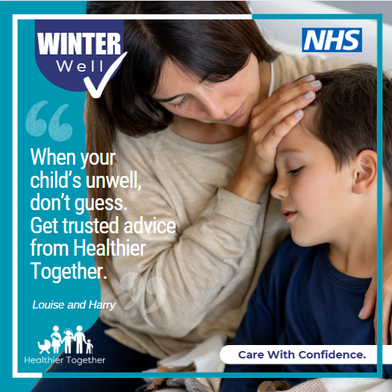 | Seek help if you’re worried.  It’s natural to feel worried when your child is unwell. The Healthier Together website can help.  It’s packed with trusted advice from local doctors and nurses, so you’ll know what to do, where to go, and when to get extra support - especially during the winter months.  Find support here on the Healthier Together website: https://tinyurl.com/79kwdumh  Care With Confidence.
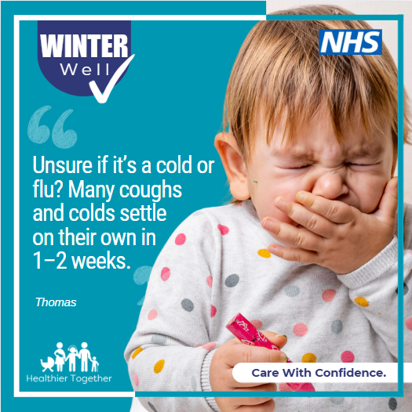 | Coughs, colds and flu.  Not sure if your child has a cough and cold, or flu?  Blocked or runny noses, sore throats, sneezing and mild fevers are very common in children and usually clear up within 1–2 weeks.  For clear advice on what to do, where to go, and when to get extra support this winter, visit the Healthier Together website: https://tinyurl.com/4r4v72jk  Care With Confidence.
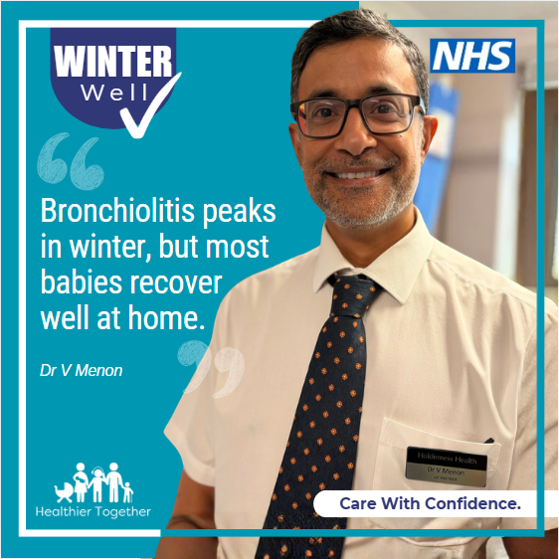 | Bronchiolitis is a common chest infection in babies and young children. It often starts like a cold but can lead to faster breathing, a cough, and less interest in feeding. Symptoms usually get worse over the first 3–4 days, then gradually improve, and most children recover without treatment.  Some babies, especially very young infants or those with other health needs, may need extra support.  If you’re worried at any point, call NHS 111.  Learn more about bronchiolitis and how to care for your child here on the Healthier Together website: https://tinyurl.com/mu52vrc7  Care With Confidence.
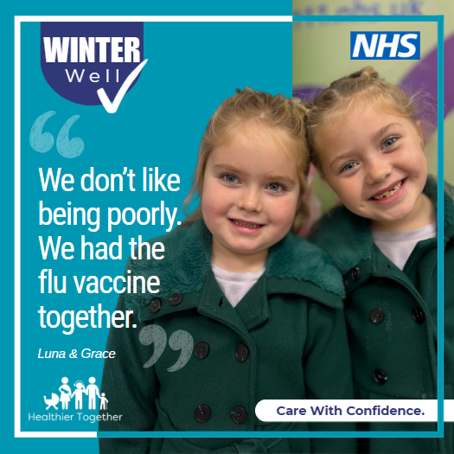 | Flu vaccine: It’s not too late  Children under 5 are more likely to need hospital care if they catch flu. The yearly flu vaccine is the best way to protect them - and the people around them.  It’s not too late to get the nasal spray flu vaccine for children.  ✅ Free for those eligible  ✅ Quick and easy to get  ✅ Available at GP practices and pharmacies  Book now at: www.letsgetvaccinated.co.uk  Care With Confidence.
Newsletter

Care With Confidence This Winter
Each winter, the NHS faces increased pressure as seasonal viruses circulate, and more children become unwell. The Healthier Together website offers clear, trusted guidance on common childhood illnesses, when and where to seek help, and where to find the right support.
It’s completely natural to feel worried when your child is unwell — but you don’t have to figure it out alone. Healthier Together is packed with reliable advice from local doctors and nurses, helping you understand what to do, where to go, and when to get extra help, especially during the busy winter months.
For clear, practical advice to help you care with confidence, visit the Healthier Together website: https://tinyurl.com/79kwdumh
It’s also not too late for your child to receive the flu vaccine. Check with your GP and find out more here: www.letsgetvaccinated.co.uk

