Choose Well - Stay Well

We know that finding the right place to go when you become ill or are injured can be confusing. By selecting the right service for your illness or injury, you’re not only looking after your health but using your NHS services responsibly and in a way that helps hardworking staff to treat and care for patients appropriately.

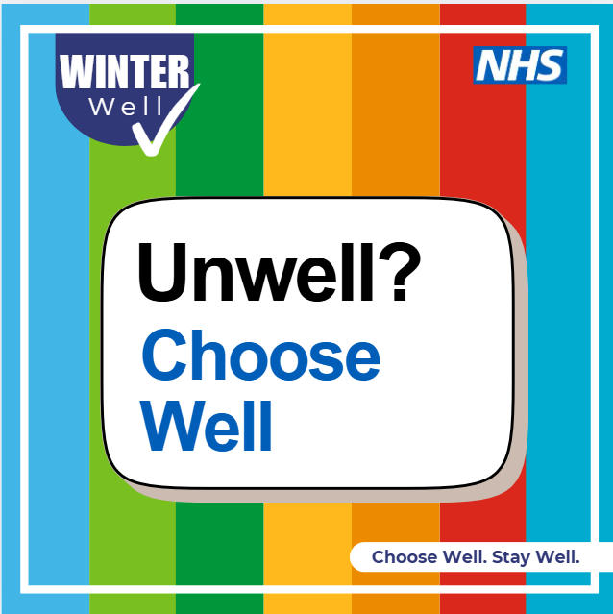 | Let’s choose well  Get the right care  We know that finding the right place to go when you become ill or are injured can be confusing. By selecting the right service for your illness or injury, you’re not only looking after your health but using your NHS services responsibly and in a way that helps hardworking staff to treat and care for patients appropriately.  Learn more about getting the right support here 👉 Get the right care - Let's Get Better  Choose Well. Stay Well
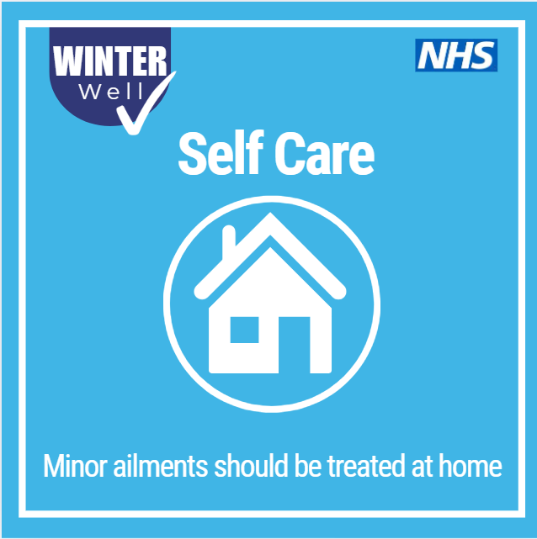 | Self-care starts with choosing well  Knowing when you can look after yourself, when a pharmacist can help, and when to get advice from your GP makes a real difference.  By choosing the right care for your illness or injury, you’re looking after your health and helping NHS staff care for those who need it most.  Learn more about self-care and getting the right support:  👉 https://letsgetbetter.co.uk/get-the-right-care/self-care/  Choose Well. Stay Well
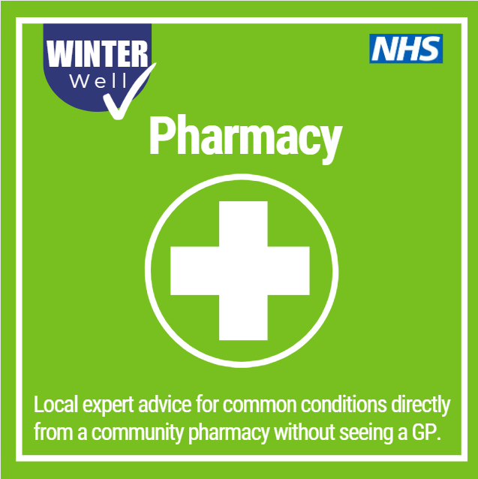 | Think Pharmacy first  Your local pharmacy is a quick, easy way to get expert healthcare advice for common illnesses like coughs, colds, aches and pains.  Highly trained pharmacy teams can assess symptoms, offer treatment, and in some cases provide prescription medicines without needing a GP appointment.  You can speak to your pharmacist in confidence, often in a private consultation area, about even the most personal health concerns.  Find out how pharmacies can help:  👉 https://www.nhs.uk/nhs-services/pharmacies/how-pharmacies-can-help/  Choose Well. Stay Well
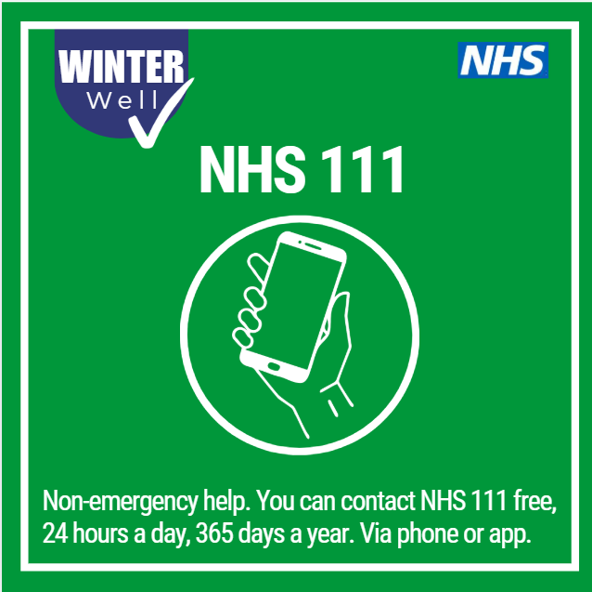 | Not sure where to go? Talk before you walk  NHS 111 is here to help if you need medical advice fast but it’s not a 999 emergency. Available free, 24/7, you can call NHS 111 or use NHS 111 online.  A trained clinical advisor will assess your symptoms and guide you to the right care, whether that’s self-care advice, a pharmacy, an urgent treatment centre, an out-of-hours GP, or another NHS service. They can even book appointments for you when needed.  Call NHS 111 if you:  - Need urgent medical help but it’s not an emergency  - Aren’t sure where to go or who to contact  - Think you may need urgent care  - Need health advice or reassurance about next steps  If you think you need medical help right now, 111 online can tell you what to do next. Get help for your symptoms - NHS 111  Choose Well. Stay Well
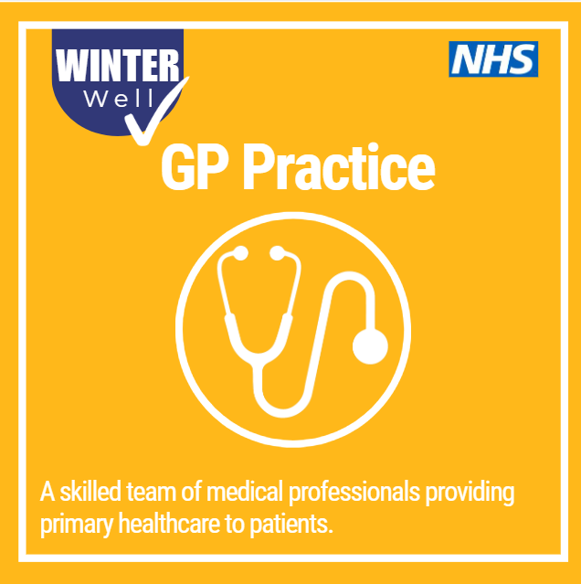 | Your GP surgery is here for you  Your local GP surgery offers a wide range of family health services—from advice on staying well and preventing illness, to vaccinations, examinations, treatment and prescriptions. They can also refer you to other health services when specialist care is needed.  GP practices have a whole team ready to help, including nurses, advanced nurse practitioners, pharmacists and healthcare assistants. You don’t always need to see a GP—the receptionist can help guide you to the right professional for your needs.  Many practices offer urgent appointments, evening and weekend services, as well as online booking, repeat prescriptions and online consultations. Remember to keep your appointment or let the surgery know if you need to cancel or change it.  Visit GP Surgery - Let's Get Better or your GP practice website to find out what services are available and how to access them.  Choose Well. Stay Well

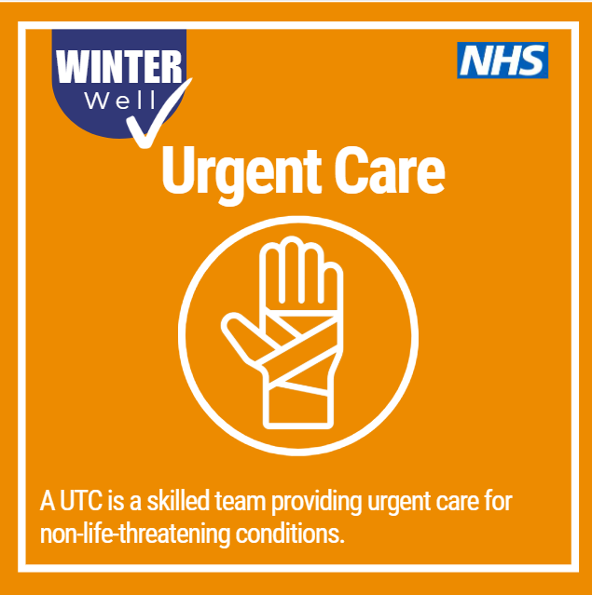 | Urgent care, not A&E  Urgent Treatment Centres treat children and adults with minor injuries and illnesses that need urgent attention but aren’t life- or limb-threatening. They’re a good alternative to A&E when you need help quickly but it’s not an emergency.  If you contact NHS 111, they can assess your symptoms and, if appropriate, book you an appointment at your nearest Urgent Treatment Centre, often saving you time and waiting. They can also advise on other nearby centres if needed.  Remember to talk before you walk  Call NHS 111 to check the right place to go and get the care you need, sooner.  Find details of your local services here Get the right care - Let's Get Better  Choose Well. Stay Well
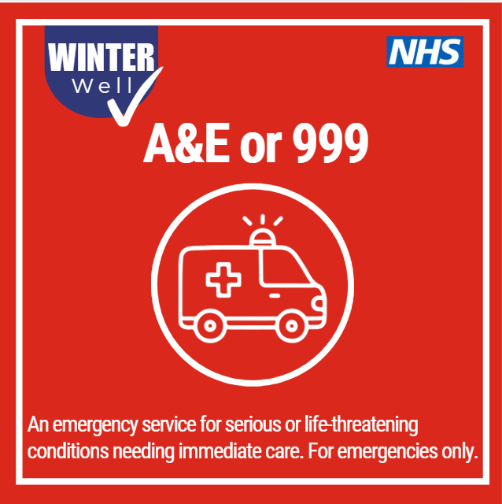 | A&E is for emergencies only  Hospital A&E departments are there for serious and life-threatening emergencies, including:  - Loss of consciousness  - Chest pain  - Breathing difficulties  - Severe bleeding  - Severe allergic reactions  - Severe burns or scalds  - Signs of a stroke  For all other urgent medical help, please talk before you walk. Visit NHS 111 online or call NHS 111 for free to get the right advice and be directed to the right service.  Choosing the right care helps you get seen faster—and keeps A&E available for those who need it most.  Choose Well. Stay Well
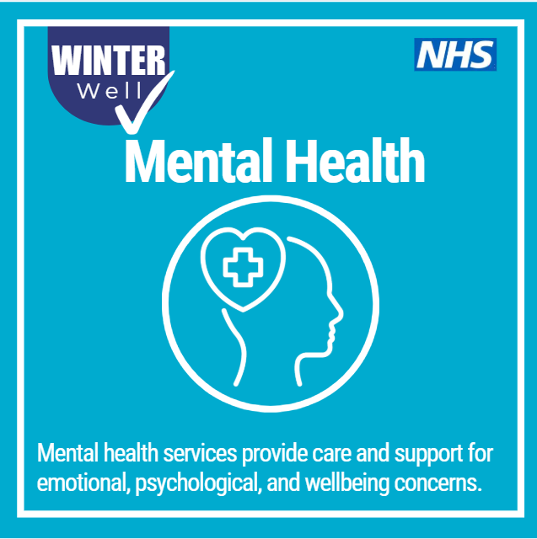 | Mental health and wellbeing matter  If you’re struggling with your mental health or wellbeing, support is available. Mental health challenges can affect many areas of life but you don’t have to face them alone.  There is both national and local help to support you, whether you’re looking for information, self-help tools, or guidance on where to get further support. The NHS website offers trusted advice on mental health and wellbeing, including how to recognise the signs that you or someone else may be struggling.  Reaching out is a positive first step. Help is here when you need it.  Find information and support for your mental health Mental health - NHS  Choose Well. Stay Well

